H.T No
Regulations:
A20

Sreenidhi Institute of Science and Technology
(An Autonomous Institution)
Code No: 8BC02 Date: 21-Aug-2023 (FN)

B.Tech I-Year II- Semester External Examination, Aug/Sept-2023 (Supplementary)
ENGINEERING GRAPHICS - (CIVIL, ECE, CSE, CS, AIML, DS and IOT)

Time: 3 Hours Max.Marks:70

Note: a) No additional answer sheets will be provided.
b) All sub-parts of a question must be answered at one place only, otherwise it will not be valued.
c) Missing data can be assumed suitably.
Bloom's Cognitive Levels of Learning (BCLL)

Remember | L1 | Apply | L3 | Evaluate | L5
Understand | L2 | Analyze | L4 | Create | L6

Part - A Max.Marks:20

Answer all QUESTIONS.

 |  | BCLL | CO(s) | Marks
1 | Define cycloid and write its applications. | L1 | CO1 | [2M]
2 | Differentiate between first angle and third angle projection methods. | L4 | CO2 | [2M]
3 | Describe different types of solids with example. | L1 | CO3 | [2M]
4 | Explain about auxiliary inclined planes and auxiliary vertical planes. | L2 | CO4 | [2M]
5 | Discuss the applications of Isometric projections. | L2 | CO5 | [2M]
6 | Write the basic commands used in AutoCAD? Write limitations. | L1 | CO6 | [2M]
7 | Distinguish between VT and HT of a line. | L2 | CO2 | [2M]
8 | Explain the importance of sectional views and development of solids. | L6 | CO4 | [2M]
9 | Write and explain Boolean operations with an example. | L1 | CO6 | [2M]
10 | What is eccentricity? | L4 | CO1 | [2M]

Part – B Max.Marks:50
ANSWER ANY FIVE QUESTIONS. EACH QUESTION CARRIES 10 MARKS.

 |  |  | BCLL | CO(s) | Marks
11. | a) | Draw a Parabola when the distance of the focus from the directrix is equal to 50mm. | L1 | CO1 | [5M]
 | b) | Draw a cycloid of circle radius 20mm. |  | CO1 | [5M]
12. |  | Compute the TL and the inclinations of the line when the end A of a straight line AB is 10 mm from the VP and 20 mm from the HP. The end B is 30 mm from the VP and 40 mm from the HP. The VT of the line is 20 mm from the end A as measured parallel to XY. Also draw the projections. | L3 | CO2 | [10M]
13. | a) | Draw the Projections for the following, when a Hexagonal plane with a 30mm side has its surface parallel to and 20mm in front of the VP.  (i) a side is perpendicular to HP (ii) Side is inclined at 45⁰ to the HP | L1 | CO3 | [5M]
 | b) | Draw projections of Pentagonal Pyramid base 25mm axis 50mm has one of its triangular face on VP. | L1 | CO3 | [5M]
14. |  | Draw the front view, sectional top view, sectional side view and true shape of the section of a pentagonal pyramid, base 30mm side and axis 65mm long, is resting on its base on the HP with an edge parallel to the VP. It is cut by a sectional plane, perpendicular to VP inclined at 45⁰ to the HP and intersecting the axis at a point 25mm above the base. Also draw the development for the retained solid. | L1 | CO4 | [10M]
15. |  | Draw the isometric view of a cone of base diameter 40 mm and height 65 mm is resting on its base on the HP. It is cut by a plane perpendicular to the VP and inclined at 45^{ᵒ} to the HP. | L1 | CO5 | [10M]
16. |  | Draw the Front view Top view and side view for the following figure.  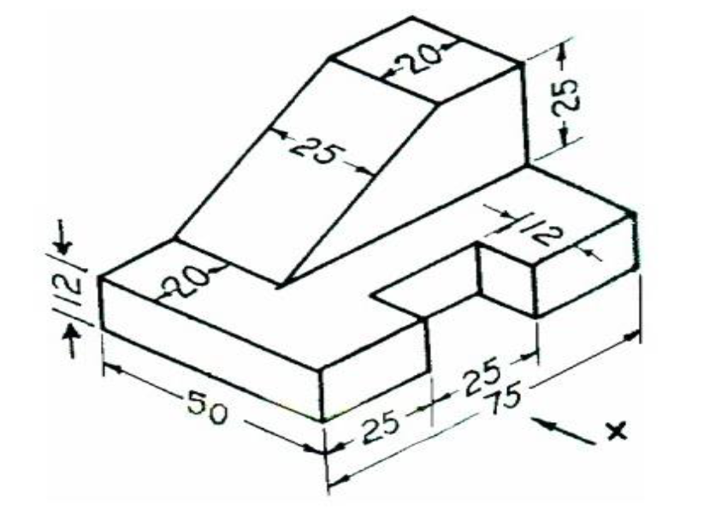 | L4 | CO6 | [10M]
17. | a) | Draw a scale of 1:5 to show decimeters and centimeters and long enough to measure up to 1 meter. Show a distance of 6.3 dm on it. | L1 | CO1 | [4M]
 | b) | Draw the projections of a 50mm long line AB is parallel to both H.P and V.P. The line is 25mm in front of V.P and 60mm above H.P. | L1 | CO2 | [3M]
 | c) | Draw the projections of a circle of diameter 50mm is parallel to HP and perpendicular to VP. If the center is 40mm in front of VP and 15mm above HP. | L1 | CO3 | [3M]
18. | a) | Draw Sectional Top View of a square prism of base 40mm and height 60mm rests with its base on the HP such that one of its edges is inclined at 30° to the VP. A section plane inclined at 60° the VP and perpendicular to the HP bisects one of the rectangular faces. | L1 | CO4 | [4M]
 | b) | Draw isometric view of a circle diameter 30mm. | L1 | CO5 | [3M]
 | c) | Draw FV and TV for the figure given below  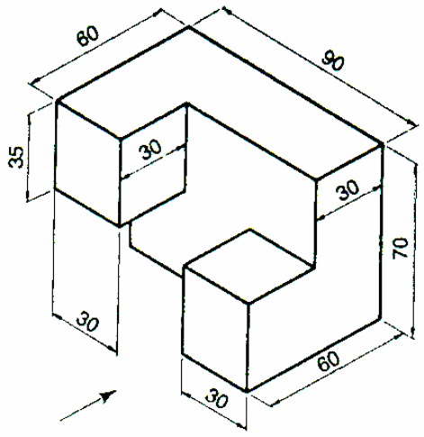 | L1 | CO6 | [3M]
-- 00 -- 00 –

